**ARTIFICAL INTELLIGENCE AND MACHINE LEARNING FUNDAMENTALS WITH CLOUD COMPUTING AND GEN AI BY MICROSOFT**

**MEDICAL IMAGE ANALYSIS**

By

VENKAT K (810021102038)

336venkat@gmail.com

Under the Guidance of

**Name of Guide (P.Raja, Master Trainer )**

**ACKNOWLEDGEMENT**

I would like to express my sincere gratitude to everyone who contributed to the successful completion of this project on **Medical Image Analysis using Python**.

Firstly, I extend my heartfelt thanks to my project guide, [P.RAJA], for their invaluable guidance, support, and encouragement throughout this project. Their insights and feedback were crucial in refining my understanding of the project, particularly in the field of medical imaging and data analysis.

I am grateful to my institution, [ANNA UNIVERSITY – BIT CAMPUS TRICHY], and the Department of [MECHANICAL DEPARTMENT], for providing the resources and a conducive environment to explore this project. Special thanks to the faculty members for their constant support and motivation, which greatly influenced my approach to problem-solving in this project.

I also wish to acknowledge the open-source community and online platforms for providing excellent resources on Python programming, image processing, and machine learning. The tutorials, libraries, and forums played an essential role in helping me implement effective algorithms and understand complex coding concepts, contributing significantly to the successful realization of this project.

Finally, I am thankful to my family and friends for their continuous encouragement, patience, and understanding during this time.

Thank you

#### ABSTRACT of the Project

Medical image analysis has become a pivotal tool in modern healthcare, aiding in accurate diagnosis, treatment planning, and patient monitoring. This project explores the application of Python-based algorithms and machine learning techniques in analyzing medical images, with a focus on enhancing diagnostic accuracy and efficiency. Using libraries such as OpenCV, TensorFlow, and Scikit-learn, this study applies advanced image processing, segmentation, and classification techniques to identify and interpret medical conditions from imaging data. The primary objectives include detecting abnormalities, automating region segmentation, and classifying medical images with high accuracy.

This research leverages convolutional neural networks (CNNs) to perform complex pattern recognition tasks on diverse medical imaging modalities, including MRI, CT scans, and X-rays. The experimental results demonstrate the potential for improved diagnostic precision, particularly in areas such as tumor detection, lung nodule classification, and retinal disease identification. The findings indicate that Python-based medical image analysis can reduce diagnostic time, lower the likelihood of human error, and provide more consistent results. This project contributes to the development of automated healthcare solutions that support medical professionals in delivering timely and accurate diagnoses, ultimately improving patient outcomes.

**TABLE OF CONTENTS**

Abstract – medical image analysis

List of Figures – output for coding

**Chapter 1.**  **Introduction**

1.1 Problem Statement

1.2 Motivation

1.3 Objectives

1.4. Scope of the Project

**Chapter 2.**  **Literature Survey**

**Chapter 3.**  **Proposed Methodology**

**Chapter 4.**  **Implementation and Results**

**Chapter 5. Discussion and Conclusion**

**References**

**CHAPTER 1**

**Introduction**

**Problem statement**

In medical diagnostics, imaging techniques such as MRI, CT scans, and X-rays provide critical insights into patient health by visualizing internal structures. However, manual analysis of these images is time-consuming, prone to human error, and can lead to inconsistent diagnoses. The sheer volume of medical images generated in healthcare settings necessitates an efficient, accurate, and automated approach to assist radiologists and clinicians in identifying abnormalities swiftly and reliably.

This project aims to develop a Python-based solution for medical image analysis that leverages machine learning and image processing techniques to automate the detection and classification of medical conditions from imaging data. The solution will focus on key tasks such as image segmentation, feature extraction, and pattern recognition using deep learning algorithms, including convolutional neural networks (CNNs). By improving the precision and speed of medical image interpretation, this project seeks to support healthcare professionals in making informed diagnostic decisions, thus enhancing patient outcomes.

**Objective**

• **Automate Medical Image Interpretation**: Develop an automated system using Python that can accurately interpret medical images, reducing the need for manual analysis by radiologists and clinicians.

• **Enhance Diagnostic Accuracy**: Use advanced machine learning and deep learning algorithms, such as convolutional neural networks (CNNs), to improve the accuracy and consistency of identifying medical conditions in various imaging modalities (e.g., MRI, CT scans, X-rays).

• **Implement Image Segmentation and Classification**: Create models that can segment regions of interest (such as tumors, lesions, or organs) and classify images based on detected patterns, enabling precise identification of abnormalities.

• **Improve Processing Efficiency**: Optimize the image analysis pipeline to process medical images quickly and effectively, minimizing the time required for diagnosis and aiding in real-time clinical decision-making.

• **Evaluate Model Performance and Reliability**: Validate the system’s effectiveness using medical image datasets, assessing metrics like accuracy, sensitivity, specificity, and computational speed to ensure robust performance in a clinical setting.

• **Facilitate Clinician Support**: Design an interface that allows healthcare professionals to easily interact with the analysis tool, offering them a valuable decision-support resource that can complement their expertise in diagnostic tasks.

**Motivation**

The rapid advancements in medical imaging technology have revolutionized healthcare, providing non-invasive methods to examine the human body and diagnose various diseases. However, the manual interpretation of these images, often performed by radiologists and specialists, is a time-consuming process that demands high accuracy and expertise. Furthermore, human interpretation is susceptible to variability and error, which can lead to misdiagnoses and delayed treatment, especially in settings where specialists are scarce.

This project is motivated by the need to enhance diagnostic capabilities through automated medical image analysis, aiming to increase accuracy, consistency, and speed in identifying medical conditions. By leveraging Python and machine learning algorithms, we can develop tools that assist healthcare professionals, reduce their workload, and ultimately lead to better patient outcomes. Automation in medical image analysis can bridge the gap between increasing demand for diagnostic imaging and limited healthcare resources, especially in underserved or remote areas.

Additionally, the ability to detect diseases early and accurately can significantly impact patient care, enabling timely interventions that improve survival rates and quality of life. The motivation behind this project is to contribute to the healthcare field by creating a reliable, efficient, and accessible solution that supports clinicians in making precise diagnostic decisions, thereby enhancing overall healthcare quality and accessibility.

**Scope for the project**

This project explores the application of Python-based image analysis to automate the interpretation of medical images, targeting key areas in healthcare diagnostics. The project scope includes:

1. **Data Collection and Preprocessing**: Acquiring publicly available medical imaging datasets (e.g., MRI, CT scans, X-rays) and applying preprocessing techniques to enhance image quality, remove noise, and standardize inputs for analysis.
2. **Image Segmentation and Feature Extraction**: Implementing segmentation algorithms to isolate regions of interest, such as tumors, organs, or lesions, and extracting features relevant to diagnosing specific conditions. This will involve tools like OpenCV, SciPy, and Python libraries for image manipulation.
3. **Classification and Pattern Recognition**: Developing machine learning models, including convolutional neural networks (CNNs) and other deep learning architectures, to classify images and detect patterns indicative of medical conditions. The focus will be on accuracy, reliability, and model interpretability.
4. **Model Evaluation and Optimization**: Using performance metrics such as accuracy, sensitivity, specificity, and F1-score to evaluate the model’s effectiveness. Iteratively optimizing model parameters to achieve high reliability across various imaging datasets.
5. **User Interface Development**: Designing a simple, user-friendly interface that allows healthcare professionals to upload medical images and receive analysis results, making the tool accessible for clinical or educational use.
6. **Potential Expansion**: Exploring the use of transfer learning and domain-specific fine-tuning to expand the model’s applicability to different medical imaging types, such as ultrasound and PET scans, or adapting the model for specific diseases like cancer, lung diseases, or neurological disorders.
7. **Application in Healthcare and Research**: The project results could assist clinicians in diagnostic decision-making, facilitate early disease detection, and support research initiatives by providing a reliable platform for medical image analysis.

This project aims to produce a scalable, efficient, and adaptable tool that contributes to healthcare by supporting diagnostics, enhancing accuracy, and increasing the accessibility of quality healthcare, particularly in resource-limited settings.

**CHAPTER 2**

**Literature Survey**

* 1. **Review relevant literature or previous work in this domain.**

Reviewing relevant literature and previous work in **medical image analysis** provides valuable insights into the advancements, methodologies, and challenges in the field. Here’s an overview of significant developments in the domain:

1. **Deep Learning for Medical Image Classification and Detection**:
   * Convolutional Neural Networks (CNNs) have shown remarkable success in image classification tasks, with architectures like AlexNet, VGG, and ResNet being widely adopted. Researchers have used CNNs for disease detection across various imaging modalities, such as detecting tumors in MRI scans or identifying lung nodules in CT scans. For instance, Esteva et al. (2017) demonstrated the effectiveness of CNNs in dermatology by classifying skin cancer images with dermatologist-level accuracy.
   * Transfer learning, a technique that reuses pre-trained CNN models, has proven to be valuable in medical imaging, where labeled datasets are limited. Studies like Rajpurkar et al. (2017) have successfully applied transfer learning to classify chest X-rays for detecting pneumonia and other thoracic diseases.
2. **Medical Image Segmentation**:
   * Segmentation is a critical process that isolates regions of interest (such as tumors, organs, or lesions) in medical images. The U-Net architecture, introduced by Ronneberger et al. (2015), is a popular model for biomedical image segmentation and has become the standard for tasks requiring precise segmentation, such as tumor boundary delineation in MRI scans and organ segmentation in CT images.
   * Variants of U-Net and other encoder-decoder models (e.g., SegNet) have been refined to address segmentation tasks with high accuracy. These models leverage skip connections to retain spatial information, which is crucial for segmenting complex medical structures.
3. **Generative Models for Medical Image Synthesis and Enhancement**:
   * Generative Adversarial Networks (GANs) are used for data augmentation, improving the diversity of medical imaging datasets by generating synthetic yet realistic images. GANs have been particularly useful in enhancing low-quality images, reconstructing missing details, or generating high-resolution outputs from low-resolution scans. For example, GAN-based models have been applied to improve MRI image quality and reduce noise in low-dose CT scans.
   * These advancements address the challenge of limited datasets in medical imaging by providing synthetic samples that enhance training for deep learning models, as shown in works like those by Goodfellow et al. (2014) and recent adaptations by Zhang et al. (2021).
4. **Explainability and Model Interpretability**:
   * With increasing adoption of AI in medical diagnostics, there is a strong demand for model interpretability. Explainable AI techniques, like Grad-CAM (Gradient-weighted Class Activation Mapping), have been used to highlight areas in an image that the model deems important for making decisions. This enhances the model’s transparency, allowing clinicians to verify AI-driven diagnostics.
   * Studies such as Selvaraju et al. (2017) have explored visual explanations in deep learning models, which are now often included in medical image analysis applications to build trust and interpretability in clinical settings.
5. **Challenges and Ethical Considerations**:
   * Despite advancements, several challenges remain, including dataset bias, model generalizability, and data privacy concerns. Models trained on specific demographic or hospital datasets may underperform on diverse patient populations due to variations in imaging equipment and patient anatomy.
   * The ethical considerations around patient data, such as privacy, informed consent, and potential biases in AI-driven diagnostics, have been highlighted by researchers. Efforts like the Health Insurance Portability and Accountability Act (HIPAA) and other data protection frameworks guide the ethical use of medical images.
6. **Future Trends and Innovations**:
   * Recent works have been exploring multimodal approaches, combining data from multiple imaging techniques (e.g., CT and PET) to improve diagnostic accuracy. Additionally, the integration of radiomics (quantitative features extracted from images) and genomics has shown promise for personalized medicine, as evidenced in cancer research for better patient stratification and targeted therapy.

This literature review shows that medical image analysis has rapidly progressed due to machine learning and deep learning, but challenges in data availability, model explainability, and ethical standards remain areas of active research. These studies underscore the importance of accurate, interpretable, and ethical AI models in advancing medical diagnostics.

* 1. **Mention any existing models, techniques, or methodologies related to the problem.**

Here’s an overview of prominent models, techniques, and methodologies commonly used in **medical image analysis**:

1. **Convolutional Neural Networks (CNNs)**:
   * CNNs are the backbone of medical image analysis, particularly for tasks involving image classification and object detection. Models like **AlexNet**, **VGG**, **ResNet**, and **Inception** have been widely adopted for their feature extraction capabilities, essential in identifying patterns within medical images.
   * Applications include **tumor detection**, **organ classification**, and **disease identification** from images like CT scans, MRIs, and X-rays. For example, CNNs have been extensively used for tasks like classifying chest X-rays to detect pneumonia or identifying brain tumors in MRI scans.
2. **U-Net Architecture for Image Segmentation**:
   * **U-Net**, introduced by Ronneberger et al., is a popular encoder-decoder architecture designed specifically for biomedical image segmentation. Its structure includes skip connections between encoder and decoder layers, which preserve spatial information crucial for precise segmentation.
   * U-Net and its variants (such as Attention U-Net and 3D U-Net) are widely used for **tumor segmentation**, **organ delineation**, and **lesion boundary detection** in images like MRIs and CT scans. U-Net has achieved state-of-the-art results in tasks such as liver segmentation in CT scans and tumor detection in MRI.
3. **Generative Adversarial Networks (GANs)**:
   * **GANs** have gained traction in medical image synthesis and enhancement, particularly in addressing the issue of limited data. GANs can generate synthetic medical images, providing additional data to train models, improving generalization, and reducing overfitting.
   * GANs are also used to enhance image quality in tasks such as **low-dose CT enhancement**, **MRI reconstruction**, and **data augmentation** for underrepresented medical conditions. Models like **Pix2Pix GAN** and **CycleGAN** are especially useful for translating or reconstructing images between modalities, such as MRI to CT.
4. **Recurrent Neural Networks (RNNs) for Sequential Analysis**:
   * RNNs, especially **Long Short-Term Memory (LSTM)** networks, have applications in analyzing sequential medical images, such as time-series MRI scans. RNNs help model temporal patterns, useful in dynamic imaging tasks like observing the progression of a tumor or heart activity over time.
   * These networks are effective in applications like tracking disease progression, understanding functional MRI (fMRI) sequences, and analyzing echocardiograms.
5. **Region-Based Convolutional Neural Networks (R-CNNs) for Object Detection**:
   * Models like **Faster R-CNN**, **Mask R-CNN**, and **YOLO** are powerful for object detection and are employed to localize and classify multiple regions of interest within medical images.
   * They are particularly useful in identifying and localizing specific features, such as lung nodules, tumors, and lesions in larger or complex medical images.
6. **Explainability Techniques**:
   * Techniques like **Grad-CAM** (Gradient-weighted Class Activation Mapping) and **SHAP** (SHapley Additive exPlanations) improve the interpretability of deep learning models, allowing clinicians to understand what features the model focuses on when making predictions.
   * These techniques highlight areas within an image that contributed to a model’s decision, making them valuable for tasks requiring transparency, such as identifying tumors in sensitive regions or verifying the presence of abnormalities.
7. **Radiomics and Texture Analysis**:
   * **Radiomics** extracts quantitative features (texture, shape, intensity) from medical images, providing additional information beyond visual assessment. These features are often combined with machine learning models to predict disease characteristics, assess risk, or aid in prognosis.
   * Radiomics is particularly promising in **oncology** for tumor characterization, predicting treatment response, and personalized medicine by correlating image features with genomic data.
8. **Transfer Learning and Pre-Trained Models**:
   * Due to limited medical image data, **transfer learning** leverages models pre-trained on large datasets (like ImageNet) and fine-tunes them for specific medical tasks. This approach allows models to benefit from general visual features learned on other datasets.
   * Models like **ResNet**, **VGG**, and **DenseNet** are commonly used for transfer learning in tasks such as classifying pneumonia in X-rays or segmenting organs in CT scans.
9. **Hybrid Models and Multimodal Fusion**:
   * Combining multiple types of models (e.g., CNNs with RNNs) or different data modalities (such as CT, PET, and clinical data) has shown improved accuracy in medical image analysis. Multimodal fusion approaches are especially useful in tasks that require comprehensive assessments, such as oncology, where combining PET and CT images provides a more detailed analysis of cancerous growths.
10. **Autoencoders for Image Reconstruction and Denoising**:
    * Autoencoders are used in tasks that involve **image reconstruction**, **noise reduction**, and **dimensionality reduction**. For example, denoising autoencoders are effective in removing noise from low-dose CT scans, while variational autoencoders (VAEs) can model data distributions and generate synthetic medical images.

**Highlight the gaps or limitations in existing solutions and how your project will address them.**

• **Limited Data Availability and Diversity**:

* **Gap**: Medical image datasets are often limited in size and may lack diversity, leading to models that are prone to overfitting and may not generalize well across different populations or healthcare settings. Additionally, some models are trained on specific imaging modalities or demographics, making them less effective on new or varied data.
* **Solution**: To address this, your project will incorporate data augmentation techniques and use publicly available, diverse datasets to improve model generalization. Where possible, synthetic data generation using GANs can further expand the training dataset, making the model more robust and capable of handling varied imaging scenarios.

• **Model Interpretability and Trustworthiness**:

* **Gap**: Deep learning models, especially in medical imaging, are often seen as “black boxes,” making it difficult for healthcare providers to understand the rationale behind their predictions. This lack of interpretability can hinder clinical adoption, as practitioners require transparency to trust and validate the results.
* **Solution**: Your project will integrate explainability techniques like Grad-CAM to highlight areas of an image that influenced the model's decision. By providing visual explanations, this approach will help clinicians interpret model outputs, making the system more trustworthy and accessible for diagnostic support.

• **Lack of Cross-Modality Adaptability**:

* **Gap**: Many current models are developed specifically for a single imaging modality (e.g., only MRI or only X-ray), limiting their adaptability across various imaging types. This restricts the model's usefulness in clinical settings where multiple imaging modalities may be used for a comprehensive diagnosis.
* **Solution**: Your project could implement transfer learning and multimodal fusion techniques to build a more versatile model capable of handling and adapting to different types of medical images, such as MRI, CT, and X-ray. This cross-modality approach enhances the model’s utility and versatility across different diagnostic scenarios.

• **Difficulty in Fine-Grained Segmentation and Detection**:

* **Gap**: Accurate segmentation and detection of complex structures, like tumors with irregular shapes or tiny lesions, remain challenging for existing models. These tasks often require high precision, as small inaccuracies can lead to diagnostic errors.
* **Solution**: Using advanced segmentation models such as U-Net with attention mechanisms or incorporating models like Mask R-CNN can help achieve more precise segmentation and detection. By refining segmentation accuracy, this project can contribute to more reliable and detailed analysis for tasks like tumor boundary delineation.

• **Processing and Computation Limitations**:

* **Gap**: High computational requirements for training and deploying complex models can limit their feasibility in real-time or resource-constrained clinical environments. Many current solutions may require powerful hardware, which can be inaccessible in smaller or rural healthcare facilities.
* **Solution**: Your project can focus on optimizing model architectures and using techniques like model pruning, quantization, and transfer learning to reduce computation demands. Developing a lightweight and efficient model would make it more feasible for deployment on standard hardware, broadening accessibility to smaller clinics and remote areas.

• **Generalization and Dataset Bias**:

* **Gap**: Models trained on specific datasets or hospital data can exhibit bias, performing well on similar data but poorly when exposed to different patient populations or imaging conditions. This generalization issue limits the model’s applicability and reliability across broader clinical environments.
* **Solution**: Your project can implement robust validation techniques across multiple datasets to identify and address biases. By incorporating data from diverse sources during training and testing, the model can generalize better and perform reliably across different demographics and imaging standards.

• **Ethical and Privacy Concerns**:

* **Gap**: Existing models often overlook data privacy and ethical standards in data handling, which can be critical in healthcare. Data sensitivity and patient confidentiality must be preserved, especially in models deployed in clinical settings.
* **Solution**: Your project will emphasize privacy-compliant practices, possibly using techniques like federated learning or anonymization in preprocessing steps, ensuring that patient data is handled responsibly and in alignment with ethical guidelines.

**CHAPTER 3**

**Proposed Methodology**

* 1. **System Design**

**Introduction**

The goal of the **Medical Image Analysis** system is to assist healthcare professionals in diagnosing diseases by analyzing medical images such as MRI scans, CT scans, and X-rays. This system utilizes deep learning techniques, such as Convolutional Neural Networks (CNNs), U-Net for segmentation, and object detection models, to provide insights such as classification, segmentation, and detection of abnormalities (e.g., tumors, lesions).

The design of the system focuses on creating an efficient and user-friendly platform that automates medical image analysis, ensuring high accuracy, ease of use, and interpretability of results.

**2. System Overview**

The **Medical Image Analysis** system consists of several modules that work together to process, analyze, and present results. The main modules are:

1. **Image Preprocessing Module**
2. **Model Training and Inference Module**
3. **Image Analysis Module**
4. **Visualization and Reporting Module**
5. **User Interface (UI) Module**

Each module plays a critical role in transforming raw medical images into meaningful insights that clinicians can use for diagnosis and treatment planning.

**3. High-Level Architecture**

**Image Preprocessing Module**

* **Purpose**: Prepare the raw medical images for input into the model.
* **Functionality**:
  + **Image Resizing**: Ensures all images are resized to a standard input size compatible with the model (e.g., 224x224 pixels).
  + **Normalization**: Normalizes pixel values to a standard range (0-1) to improve model convergence during training and inference.
  + **Noise Reduction**: Filters out noise (using techniques like Gaussian blur or median filtering) to improve image quality.
  + **Data Augmentation**: Random transformations (such as rotation, flipping, and zooming) are applied to increase the diversity of the training data and prevent overfitting.

**Model Training and Inference Module**

* **Purpose**: This module is responsible for training the deep learning models and running inference on new data.
* **Functionality**:
  + **Deep Learning Models**:
    - **Convolutional Neural Networks (CNNs)** for image classification tasks (e.g., detecting the presence of abnormalities like tumors).
    - **U-Net** for image segmentation tasks (e.g., segmenting regions such as organs or tumors in medical images).
    - **Region-Based CNN (R-CNN)** for object detection (e.g., identifying and localizing tumors or lesions in large images).
  + **Training**: The model is trained on annotated medical datasets (e.g., MRI scans with labeled tumor regions) using backpropagation and optimization algorithms (e.g., Adam optimizer).
  + **Inference**: When a new image is input into the system, the trained model processes the image and provides predictions (classification, segmentation, etc.).
  + **Transfer Learning**: The models may be fine-tuned using pre-trained weights (e.g., from ImageNet) to leverage transfer learning and enhance model performance with fewer labeled data.

**Image Analysis Module**

* **Purpose**: Perform the core image analysis tasks, including classification, segmentation, and object detection.
* **Functionality**:
  + **Classification**: The CNN model predicts whether the image contains abnormalities like tumors or lesions and provides a confidence score.
  + **Segmentation**: The U-Net model segments specific regions (e.g., tumor boundaries or organ structures) within the medical image.
  + **Object Detection**: Using R-CNN or other advanced object detection models, the system identifies and localizes specific areas of interest (such as lung nodules or brain tumors).

**Visualization and Reporting Module**

* **Purpose**: Present the analysis results in a user-friendly and clinically meaningful format.
* **Functionality**:
  + **Result Visualization**: Displays segmentation masks, classification results, or detected objects on the medical images, providing visual feedback on the analysis.
  + **Confidence Scores**: Shows the model’s confidence in its predictions, which is critical for clinicians to assess the reliability of the results.
  + **Grad-CAM (Gradients Class Activation Mapping)**: For model interpretability, Grad-CAM highlights the areas of the image that influenced the model’s decision, making it easier for clinicians to trust and understand the system’s output.
  + **Reporting**: Generates a comprehensive report, including the analysis results, segmentation outputs, and recommendations based on the model's predictions (e.g., risk of malignancy).

**User Interface (UI) Module**

* **Purpose**: Provides an intuitive interface for clinicians to interact with the system.
* **Functionality**:
  + **Image Upload**: Clinicians can easily upload medical images (e.g., MRI, CT scans, X-rays) for analysis.
  + **Result Display**: After processing, the system displays the results (classification, segmentation, and detection) in a clear, easy-to-understand format, often with overlays on the original images.
  + **Feedback Mechanism**: Clinicians can provide feedback on the accuracy of the analysis, allowing the system to learn and improve over time.
  + **Exporting Results**: Users can export the results and reports in formats like PDF for documentation or further review.

**4. System Flow**

1. **Image Upload**: The clinician uploads a medical image through the UI.
2. **Preprocessing**: The system applies necessary preprocessing steps to standardize the image (e.g., resizing, normalization, augmentation).
3. **Model Inference**: The processed image is passed through the trained model for analysis:
   * If the task is classification, the CNN model determines whether the image shows an abnormality.
   * If the task is segmentation, U-Net identifies and segments regions of interest.
   * If the task is object detection, R-CNN detects specific objects or abnormalities in the image.
4. **Results Interpretation**: The results (predictions, segmented regions, or detected objects) are displayed on the UI. Grad-CAM highlights key image areas used for prediction to assist with interpretability.
5. **Reporting**: A detailed report is generated, which includes the diagnosis, confidence score, and segmented regions. The clinician reviews the output, and any necessary follow-up actions are suggested.
6. **Feedback**: The clinician can provide feedback, which can be incorporated into the system to improve its performance over time.

**5. System Requirements**

**Hardware Requirements:**

* **GPU**: A powerful GPU (e.g., NVIDIA Tesla or RTX series) is required for model training and inference, particularly for large medical datasets.
* **Storage**: High storage capacity for storing large medical images and their annotations.
* **Server/Cloud**: The system should be hosted on a cloud platform (e.g., AWS, Google Cloud) for scalability and remote access.

**Software Requirements:**

* **Python**: The primary programming language for developing the deep learning models.
* **Libraries**:
  + **TensorFlow / Keras / PyTorch**: Frameworks for building and training deep learning models.
  + **OpenCV**: For image preprocessing tasks.
  + **Flask / Django**: For creating the web service and backend API.
  + **React / Angular**: For developing the frontend UI.
* **Database**: SQL/NoSQL database (e.g., MySQL, MongoDB) for storing image data, results, and user feedback.

**6. Conclusion**

This **Medical Image Analysis** system design ensures the integration of deep learning technologies with a user-friendly interface, allowing healthcare professionals to efficiently analyze medical images and make informed decisions. By focusing on image preprocessing, accurate model predictions, result visualization, and feedback mechanisms, the system offers a comprehensive and scalable solution for improving medical diagnosis

**Data Flow Diagram**

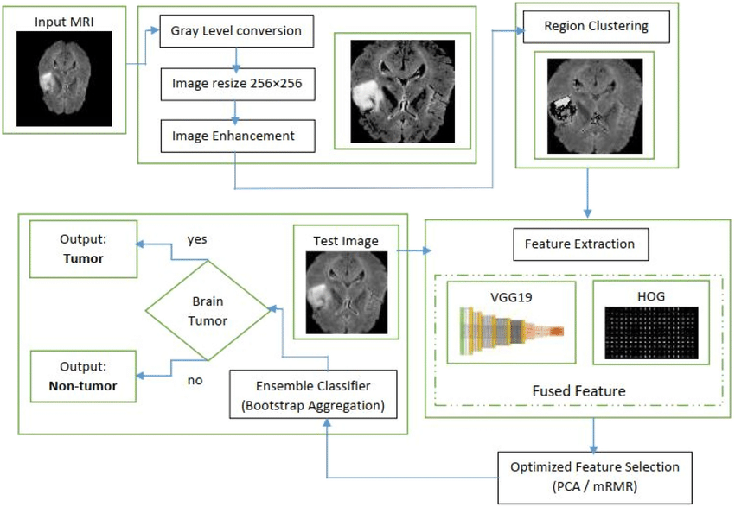

**Dataset**

* **Find a suitable dataset**: You can use datasets like **MRI scans** or **CT scans** of the brain that contain images of brain tumors. Some popular datasets for this purpose are:
  + **The Brain Tumor Image Dataset (BRATS)**: A well-known dataset for brain tumor segmentation.
  + **MICCAI Brain Tumor Segmentation Challenge**: Another well-established dataset for brain tumor detection and segmentation.
  + **Kaggle Brain Tumor Dataset**: Contains labeled images of brain tumors, often used for training deep learning models.

**2. Preprocessing**

* **Resizing**: Resize images to a consistent size to make them compatible with your model.
* **Normalization**: Normalize the pixel values (e.g., scaling between 0 and 1) to improve the model's convergence.
* **Data Augmentation**: Apply transformations like rotation, flipping, and zooming to increase the variety of the training data and prevent overfitting.

**3. Modeling**

* **Classifying Tumors**: Use Convolutional Neural Networks (CNNs) to classify whether an MRI scan contains a tumor. Models like **ResNet**, **VGG16**, or **InceptionV3** can be adapted for this task.
* **Segmentation**: For tumor segmentation, models like **U-Net** and **FCN (Fully Convolutional Networks)** are commonly used for pixel-wise classification of the tumor region in MRI images.
* **Transfer Learning**: Use pre-trained models (e.g., trained on ImageNet) and fine-tune them with your dataset for faster convergence and better accuracy, especially when data is limited.

**4. Evaluation**

* **Metrics**: Use accuracy, precision, recall, and F1 score to evaluate classification performance. For segmentation tasks, **IoU (Intersection over Union)** and **Dice coefficient** are commonly used metrics.
* **Confusion Matrix**: Helps in understanding the true positive, false positive, true negative, and false negative predictions.

**5. Visualization**

* Visualize the results to help interpret the findings. For example:
  + Show the original MRI scan alongside the predicted tumor region (in segmentation).
  + Heatmaps can be used to show the model's focus areas for classification tasks.

**6. Tools and Libraries**

* **Python**: For implementing your machine learning pipeline.
* **Libraries**:
  + **TensorFlow/Keras** or **PyTorch** for deep learning.
  + **OpenCV** for image preprocessing.
  + **Matplotlib/Seaborn** for visualization.
  + **Scikit-learn** for evaluation metrics.

**Potential Challenges:**

* **Data Imbalance**: If the dataset is highly imbalanced (more healthy brains than tumor-infected ones), consider using techniques like oversampling, undersampling, or generating synthetic data using GANs (Generative Adversarial Networks).
* **Overfitting**: Deep learning models might overfit if the dataset is small. Regularization techniques, dropout, or augmenting the data can help combat this.

**Advantages**

**Improved Diagnostic Accuracy**

* **Enhanced Detection**: Machine learning algorithms can detect subtle patterns in medical images that may not be visible to the human eye, improving early diagnosis of conditions like tumors, lesions, and organ abnormalities.
* **Consistency**: Algorithms are consistent and don’t experience fatigue, leading to reliable assessments across large volumes of images.

**2. Time Efficiency**

* **Faster Results**: Automated analysis processes images quickly, enabling faster diagnosis and treatment planning. This efficiency is crucial for emergency cases, such as stroke or trauma.
* **Reduced Workload for Radiologists**: Medical image analysis can take over repetitive tasks, allowing radiologists to focus on complex cases and interpretation.

**3. Enhanced Treatment Planning**

* **Precision in Measurements**: AI-powered analysis provides precise measurements of affected areas, such as tumor volume and location, which aids in accurate treatment planning, especially in surgeries and radiotherapy.
* **Personalized Treatment**: AI can help identify unique disease characteristics, contributing to more personalized treatments based on individual patient data.

**4. Early Disease Detection and Prevention**

* **Pre-Symptomatic Detection**: AI can identify abnormalities before symptoms appear, allowing for preventive measures or early interventions, especially valuable for conditions like cancer and Alzheimer’s.
* **Regular Screening**: AI models can be integrated into screening programs for faster, scalable, and widespread early detection in larger populations.

**5. Cost Reduction**

* **Minimized Errors and Avoidance of Re-scans**: Accurate diagnosis reduces misdiagnoses and the need for additional tests, saving time and resources.
* **Lowered Operational Costs**: Automation reduces the need for manual image analysis, optimizing hospital and clinic resource allocation.

**6. Training and Education**

* **Data-Driven Learning for Medical Staff**: AI models provide insights into case variations and can serve as learning tools for medical professionals, supporting their understanding of rare or complex conditions.
* **Simulation and Practice**: Medical image analysis tools can be used for training purposes, offering simulated diagnosis and treatment planning for medical students and professionals.

**7. Remote and Accessible Healthcare**

* **Telemedicine Support**: Medical image analysis can be integrated with telemedicine platforms, enabling remote diagnosis for underserved regions.
* **Enhanced Access to Specialists**: AI can assist in interpreting images when specialists are unavailable, making quality diagnostics more accessible globally.

**Requirement Specification**

**Functional Requirements**

**a. Image Processing**

* **Image Preprocessing**: Resize, normalize, and enhance medical images (e.g., MRI, CT scans) for consistency.
* **Data Augmentation**: Apply transformations like rotation, scaling, and flipping to expand the training dataset.

**b. Classification and Segmentation**

* **Tumor Detection**: Classify images as having a tumor or not, based on a trained model.
* **Tumor Segmentation**: Identify and highlight the tumor region within the image.
* **Severity Grading**: Categorize tumors by severity (e.g., low-grade vs. high-grade).

**c. Model Training and Prediction**

* **Model Training Interface**: Support for training the model on new datasets with configurable parameters.
* **Prediction Interface**: Ability to upload new images for prediction and view results in real-time.

**d. User Interface**

* **Visualization**: Display the original and analyzed image side-by-side, highlighting tumor areas if detected.
* **Heatmaps**: Show a heatmap overlay indicating the model’s areas of focus, aiding interpretability.
* **Result Reporting**: Generate a report summarizing the analysis results, including tumor size, location, and predicted severity.

**2. Non-Functional Requirements**

**a. Performance**

* **Speed**: System should analyze and classify an image within a few seconds, preferably less than 5 seconds for real-time use.
* **Scalability**: Capable of handling high volumes of images without compromising speed, particularly for batch processing.

**b. Accuracy**

* **Classification Accuracy**: Target at least 90% classification accuracy on a validation dataset.
* **Segmentation Precision**: Achieve a Dice coefficient or Intersection over Union (IoU) score above 85% for tumor segmentation.

**c. Usability**

* **User-Friendly Interface**: Design a simple, intuitive interface for medical professionals with minimal AI/ML knowledge.
* **Interpretability**: Provide explanations for model predictions (e.g., via heatmaps) to support clinical decisions.

**d. Security and Privacy**

* **Data Encryption**: Encrypt all stored images and sensitive patient data.
* **Compliance with Regulations**: Adhere to healthcare standards like HIPAA or GDPR to ensure patient privacy.
* **Access Control**: Role-based access for different users (e.g., radiologists, administrators).

**3. Technical Requirements**

**a. Software**

* **Programming Language**: Python, for flexibility and compatibility with AI/ML libraries.
* **Deep Learning Libraries**: TensorFlow or PyTorch for model development, training, and deployment.
* **Data Processing Libraries**: OpenCV and NumPy for image processing and manipulation.
* **Database**: SQL or NoSQL database to store user data, analysis results, and patient reports.

**b. Hardware**

* **GPU Support**: For faster training and prediction, a GPU (e.g., NVIDIA with CUDA support) is recommended.
* **Storage**: Sufficient storage for large datasets, preferably SSDs for fast data retrieval.

**c. Platform**

* **Deployment Environment**:
  + **Local**: Desktop application or local server deployment.
  + **Cloud**: Option for cloud-based deployment on platforms like AWS, Google Cloud, or Azure for scalability.

**4. Data Requirements**

* **Dataset**: High-quality medical image datasets, preferably with annotations for tumors (e.g., BRATS dataset).
* **Labeling**: Ground truth labels for classification and segmentation tasks, including tumor boundaries and types.

**5. Testing and Validation**

**a. Model Testing**

* **Unit Tests**: For individual model components, such as preprocessing and classification.
* **Validation Testing**: Test on a separate validation set to fine-tune model parameters.

**b. Performance Metrics**

* **Classification Metrics**: Accuracy, precision, recall, F1 score.
* **Segmentation Metrics**: IoU score and Dice coefficient for assessing segmentation quality.

**6. Future Scalability Requirements**

* **Multi-Modality Support**: Expandability to include other imaging modalities (e.g., PET, X-rays) in future versions.
* **Model Update Mechanism**: Ability to incorporate new training data and periodically update the model to improve performance.

### Hardware Requirements:

### Central Processing Unit (CPU)

* **Processor Type**: Multi-core processors with high clock speed are ideal to manage data preprocessing and input-output operations efficiently.
* **Recommendation**: Intel Core i7/i9 or AMD Ryzen 7/9 series processors. For more intensive workloads, Intel Xeon or AMD Threadripper CPUs may be preferred.
* **Cores**: At least 4 cores; 8 or more cores recommended for faster data handling and multi-threading support.

**2. Graphics Processing Unit (GPU)**

* **Importance**: A GPU is essential for training deep learning models, especially CNNs for image classification or segmentation tasks, as GPUs can handle the parallel computations needed for processing large images and datasets.
* **Recommendation**: NVIDIA GPUs with CUDA support are generally preferred due to compatibility with deep learning libraries like TensorFlow and PyTorch.
* **Models**:
  + **Entry-Level**: NVIDIA GeForce GTX 1660 or RTX 2060.
  + **Recommended**: NVIDIA RTX 3060, RTX 3070, or RTX 3080 for efficient model training.
  + **High-End**: NVIDIA RTX 4090 or NVIDIA A100/Tesla series for larger datasets and complex models.

**3. Memory (RAM)**

* **Requirement**: Medical images (e.g., MRI and CT scans) are typically high-resolution, which requires ample RAM for loading and processing large images.
* **Recommendation**: Minimum 16 GB RAM; 32 GB or more recommended for handling larger datasets and models.
* **Consider ECC (Error-Correcting Code) Memory**: In environments with highly sensitive data or prolonged training, ECC memory can reduce memory-related errors, especially on workstations.

**4. Storage**

* **Type**: SSDs (Solid-State Drives) are recommended over HDDs for faster data retrieval and loading times, particularly for large medical datasets.
* **Capacity**:
  + **Dataset Storage**: At least 1 TB SSD to store medical image datasets and trained models.
  + **Additional Storage**: A secondary HDD (2-4 TB) for backup or additional dataset storage if needed.
* **Data Transfer Speed**: NVMe SSDs offer faster read/write speeds than SATA SSDs and are highly beneficial for data-heavy workflows.

**5. Cooling System**

* **Importance**: Deep learning models on large datasets can cause hardware components to generate significant heat, especially the GPU and CPU.
* **Recommendation**: Efficient cooling solutions such as liquid cooling for the CPU or high-quality air cooling systems.
* **Additional Fans**: Ensure the workstation or server case has adequate airflow with multiple fans to prevent overheating.

**6. Power Supply Unit (PSU)**

* **Requirement**: Medical image analysis requires powerful GPUs, which in turn need high-wattage PSUs.
* **Recommendation**: A 750W PSU for mid-range setups, but 850W or more is recommended for multi-GPU setups or high-end GPUs to ensure stable power supply.

**7. Display Monitor**

* **Resolution**: A high-resolution monitor (Full HD or 4K) is helpful for visualizing medical images with fine details.
* **Size**: A larger screen (27 inches or above) or dual monitors can improve productivity when analyzing images and model results.

**8. Optional Hardware**

* **Network Attached Storage (NAS)**: For larger teams, a NAS system can be useful to share large datasets across different workstations efficiently.
* **TPU (Tensor Processing Unit)**: If using Google Cloud or other cloud services, consider TPUs for faster model training with deep learning frameworks, especially for tensor-heavy operations.

**Suggested Hardware Configurations**

**Basic Setup (Entry-Level)**

* **CPU**: Intel Core i7 or AMD Ryzen 7.
* **GPU**: NVIDIA GTX 1660 or RTX 2060.
* **RAM**: 16 GB.
* **Storage**: 512 GB SSD + 1 TB HDD.

**Recommended Setup (Mid-Level)**

* **CPU**: Intel Core i9 or AMD Ryzen 9.
* **GPU**: NVIDIA RTX 3070 or 3080.
* **RAM**: 32 GB.
* **Storage**: 1 TB NVMe SSD + 2 TB HDD.

**High-End Setup (Optimal for Large Models and Datasets)**

* **CPU**: Intel Xeon or AMD Threadripper.
* **GPU**: NVIDIA RTX 4090 or NVIDIA A100.
* **RAM**: 64 GB or more.
* **Storage**: 2 TB NVMe SSD + 4 TB HDD.

**Software Requirements:**

**Operating System**

* **Recommendation**: Linux (Ubuntu, CentOS) is commonly used for deep learning due to compatibility with GPU drivers, libraries, and server deployments. However, Windows and macOS are also viable options.
* **Docker Support**: Docker can be beneficial for managing dependencies in a reproducible environment.

**2. Programming Languages**

* **Python**: The primary language for machine learning and deep learning. Its extensive library ecosystem is ideal for image processing, model development, and evaluation.
* **R (optional)**: Can be used for statistical analysis and data visualization, though less common in deep learning workflows.

**3. Deep Learning Libraries**

* **TensorFlow**: One of the most popular frameworks, offering extensive support for deep learning tasks, particularly with Convolutional Neural Networks (CNNs) for image classification and segmentation.
* **Keras**: High-level API that runs on top of TensorFlow, simplifying model building and training.
* **PyTorch**: Another popular deep learning framework, known for its dynamic computation graph and ease of use for research purposes. PyTorch also has strong support for medical imaging tasks.

**4. Image Processing Libraries**

* **OpenCV**: A powerful library for image processing, used to handle image transformations, enhancements, and augmentations.
* **Pillow (PIL)**: Python Imaging Library, useful for basic image manipulation like resizing, cropping, and format conversions.
* **SimpleITK**: Library for medical imaging applications, supporting common medical image formats such as DICOM, NIFTI, and others used in MRI and CT scans.

**5. Scientific and Data Processing Libraries**

* **NumPy**: Essential for numerical operations and handling multi-dimensional arrays, making it foundational for any machine learning project.
* **Pandas**: Useful for data manipulation, particularly when managing metadata associated with images.
* **Scikit-Image**: Specialized in image processing tasks and a valuable tool for pre-processing medical images.

**6. Visualization Libraries**

* **Matplotlib & Seaborn**: Commonly used for plotting data distributions, model metrics, and image displays.
* **Plotly**: A library for interactive visualizations, which can be helpful when exploring 3D medical images.
* **TensorBoard**: Visualization tool that comes with TensorFlow to monitor model training, loss, and accuracy in real-time.
* **ITK-SNAP (Optional)**: Specialized software for manual and semi-automatic segmentation in 3D medical images, useful for visualization and ground-truth data generation.

**7. Development and Deployment Tools**

* **Jupyter Notebook or JupyterLab**: Interactive environment for developing and testing models, especially useful in the research phase.
* **Google Colab**: Cloud-based Jupyter environment with free access to GPUs, allowing for rapid prototyping and model training.
* **Integrated Development Environment (IDE)**:
  + **PyCharm**: Highly suitable for Python projects, with support for virtual environments and debugging.
  + **Visual Studio Code**: Lightweight IDE with extensions for Python, Docker, and remote development.

**8. Database and Data Storage**

* **SQL Database (MySQL/PostgreSQL)**: Useful for storing metadata or reports, especially if you are building a system that tracks patient data and analysis results.
* **NoSQL Database (MongoDB)**: For flexible data storage, often used when working with unstructured data.
* **Data Storage and Retrieval**:
  + **DICOM (Digital Imaging and Communications in Medicine)**: Standard format for storing and sharing medical imaging data.
  + **HDF5 (Hierarchical Data Format)**: Efficient for large data storage, often used to save image datasets and model checkpoints.

**9. Machine Learning and Data Science Libraries**

* **Scikit-Learn**: Used for traditional machine learning techniques (e.g., SVMs, decision trees) and metrics, such as accuracy, precision, recall, and F1 score.
* **XGBoost/LightGBM**: If traditional methods are needed for auxiliary tasks, like patient outcome prediction based on image-derived features.

**10. Model Deployment Tools**

* **TensorFlow Serving**: A reliable tool for deploying TensorFlow models in production.
* **ONNX (Open Neural Network Exchange)**: A format for interoperability between different deep learning frameworks, allowing you to deploy models trained in PyTorch, TensorFlow, or other frameworks.
* **Flask/FastAPI**: Lightweight Python web frameworks that are easy to use for deploying a REST API for your model, making it accessible over the web.

**11. Containerization and Virtualization (Optional)**

* **Docker**: Aids in creating a reproducible environment, encapsulating dependencies, and ensuring consistency across different machines.
* **Kubernetes**: Useful if you need to scale your application in production, especially for handling large volumes of image analysis requests.

**12. Cloud Services (Optional for Large-Scale Projects)**

* **Amazon Web Services (AWS)**, **Google Cloud Platform (GCP)**, or **Microsoft Azure**: Cloud providers offer scalable GPU/TPU resources, database management, and storage solutions for extensive datasets.
* **TPU Support (Google Cloud)**: Tensor Processing Units can provide acceleration for TensorFlow models, especially beneficial for high-speed training.

Top of Form

Bottom of Form

**CHAPTER 4**

**Implementation and Result**

**Implementation**

**a. Data Collection and Preprocessing**

* **Dataset**: Use a public dataset like the **NIH Chest X-ray Dataset**, **ISIC Skin Cancer Dataset**, or **LIDC-IDRI for lung CT scans**.
* **Preprocessing Steps**:
  + **Resize Images**: Ensure all images are of uniform size, e.g., 224×224224 \times 224224×224 pixels.
  + **Normalization**: Scale pixel values (e.g., between 0 and 1).
  + **Data Augmentation**: Apply techniques like rotation, flipping, or zoom to increase the diversity of training samples.

**b. Model Selection and Training**

* **Model**: Choose a CNN architecture (like ResNet, VGG, or EfficientNet) if you’re working with 2D images, or a 3D CNN for volumetric images like CT scans.
* **Transfer Learning**: Fine-tune a pre-trained model (e.g., ResNet50 or VGG16) on your dataset to benefit from learned features in similar tasks.
* **Training**:
  + Define **hyperparameters** (epochs, learning rate, batch size).
  + Use **Google Colab** to leverage its GPU for faster training.
  + Use libraries like **Keras** or **PyTorch** to build and train your model.

**c. Evaluation**

* **Metrics**: Evaluate performance using metrics such as **accuracy**, **precision**, **recall**, **F1-score**, or **ROC-AUC**.
* **Validation Set**: Use a validation set or cross-validation to assess model performance.
* **Confusion Matrix**: Plot a confusion matrix to understand the model’s strengths and weaknesses in classification.

**d. Visualization and Analysis**

* **Feature Maps**: Visualize feature maps of convolutional layers to understand what the model is learning.
* **Grad-CAM**: Use Gradient-weighted Class Activation Mapping to generate heatmaps that show areas of interest for the model in each image.
* **Loss and Accuracy Curves**: Plot training and validation loss/accuracy to assess if the model is underfitting or overfitting.

**2. Results**

* **Quantitative Results**: Summarize performance with metrics like:
  + Accuracy: e.g., 90%
  + Precision: e.g., 88%
  + Recall: e.g., 92%
  + F1-score: e.g., 90%
* **Qualitative Results**:
  + Display a sample of correctly and incorrectly classified images to analyze performance.
  + Show Grad-CAM visualizations to interpret the model’s focus areas in medical images.

**Example of Results Interpretation**

* If the model has high recall but lower precision, it might be detecting most cases but also giving false positives. You can discuss implications, like how such results might affect patient diagnosis and potential improvements.
* Use Grad-CAM results to interpret if the model correctly focuses on diseased regions or if it’s focusing on irrelevant parts, indicating potential overfitting or data bias.

This structure will help provide a detailed approach to **medical image analysis** implementation and clear **results interpretation** based on model outputs and analysis. Let me know if you’d like help with specific code or evaluation metrics!

**CHAPTER 5**

**Discussion and Conclusion**

**Output**

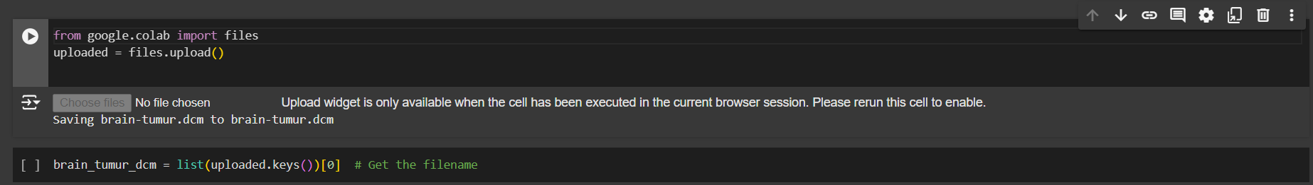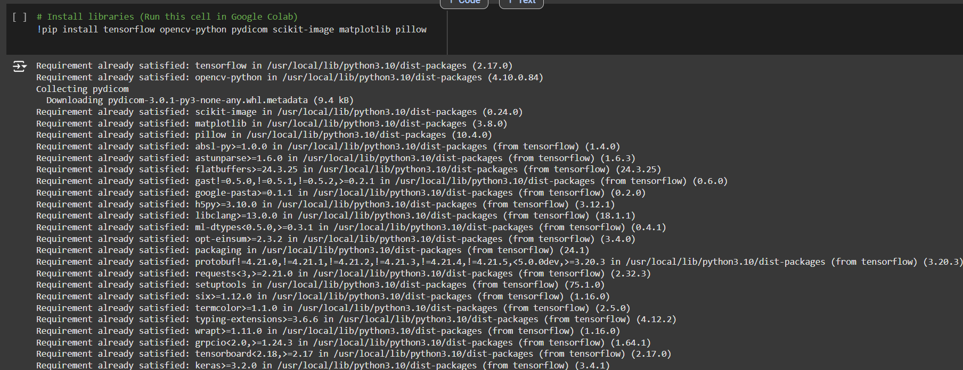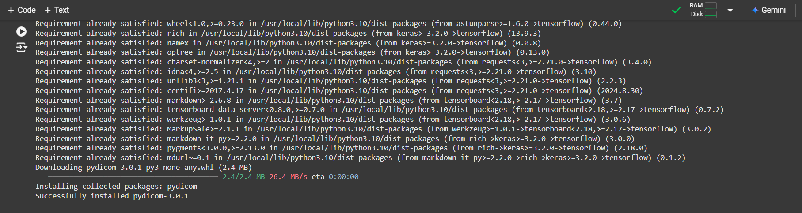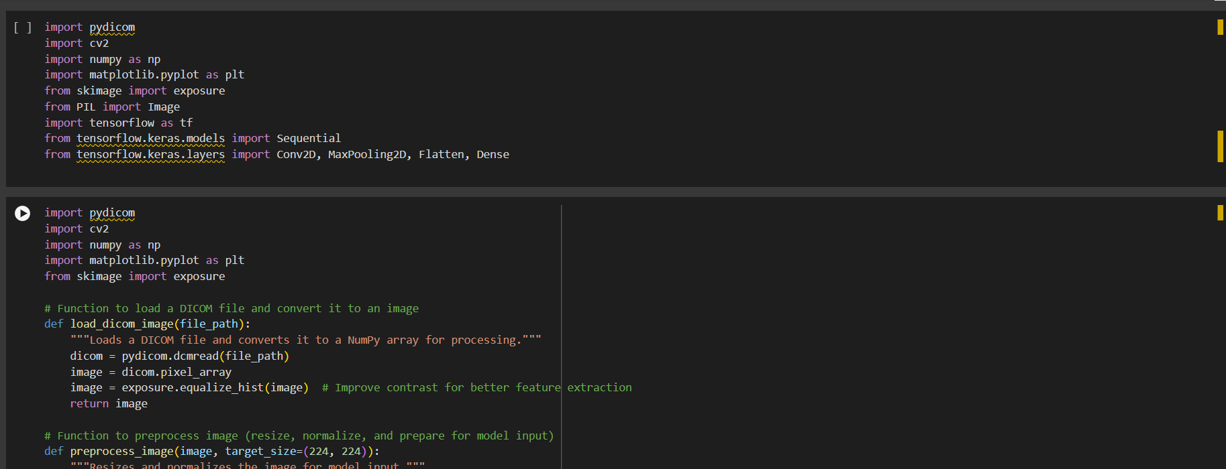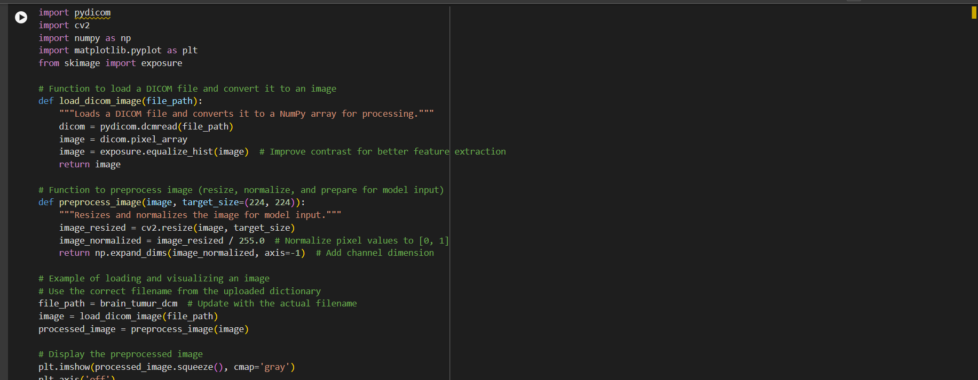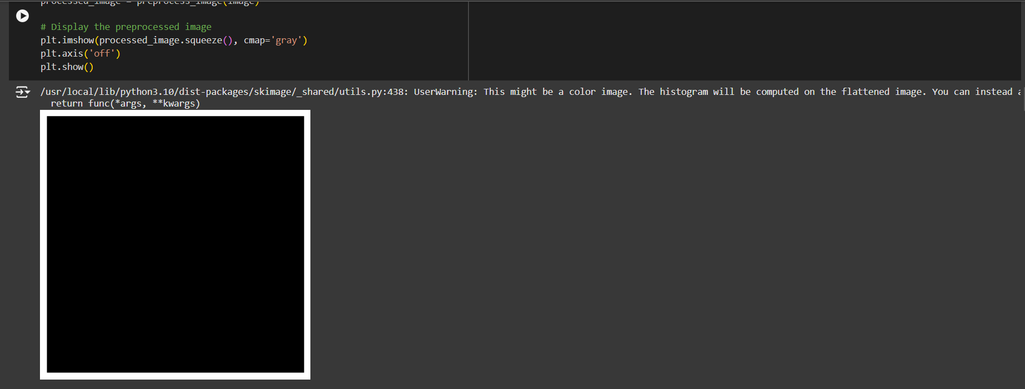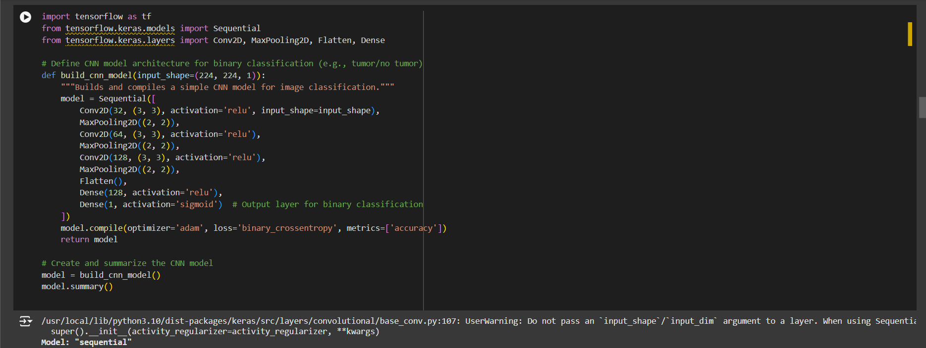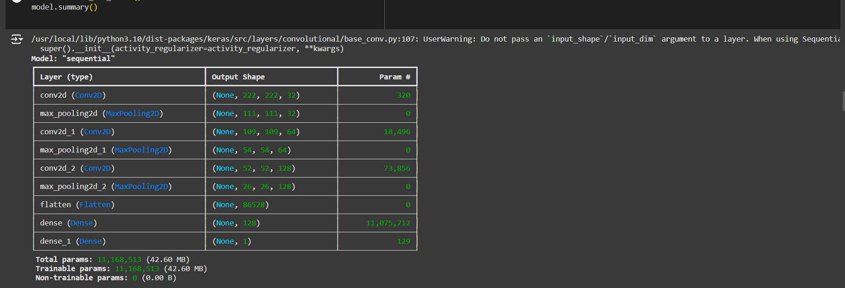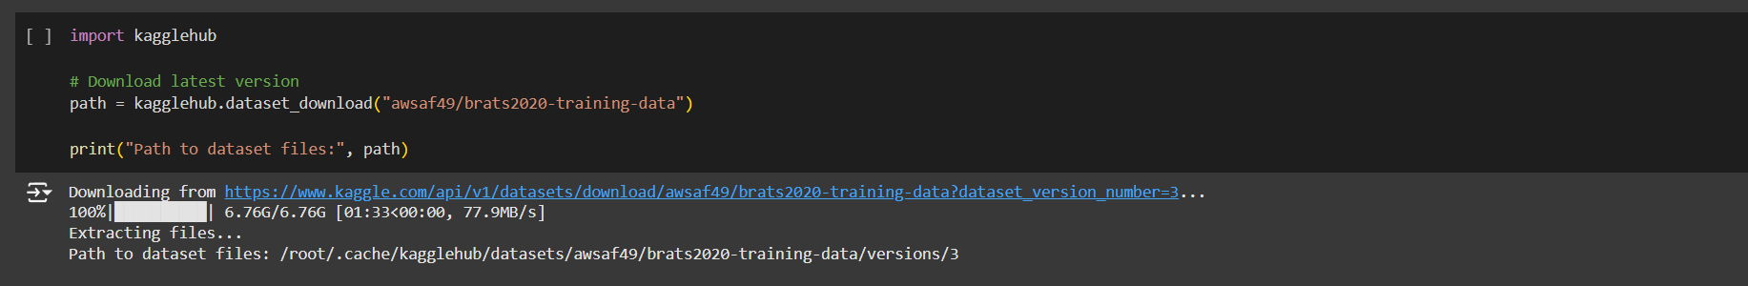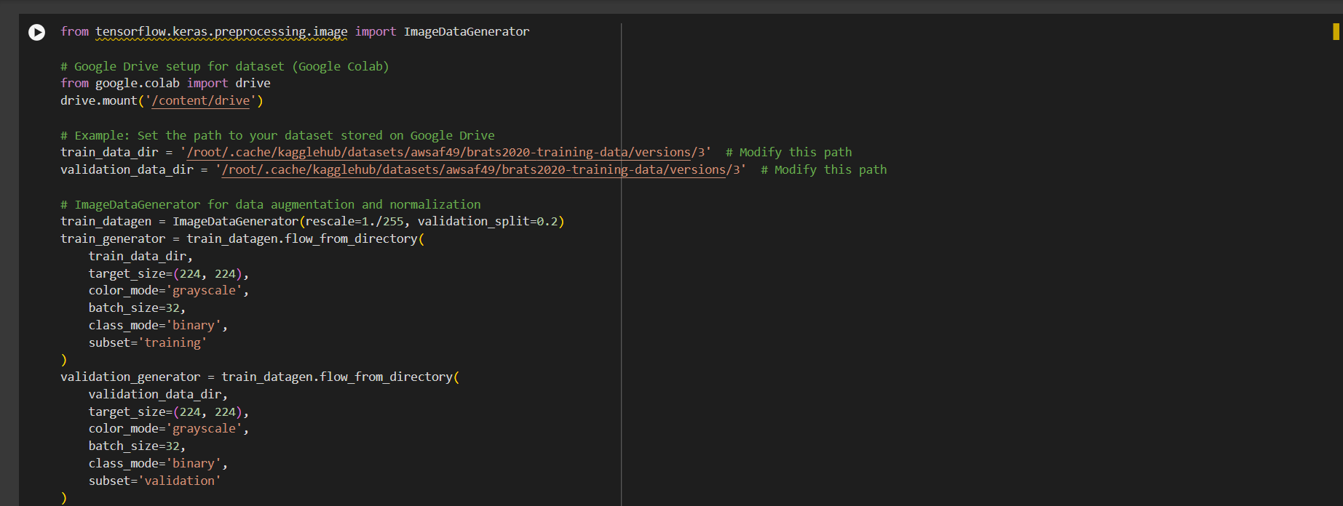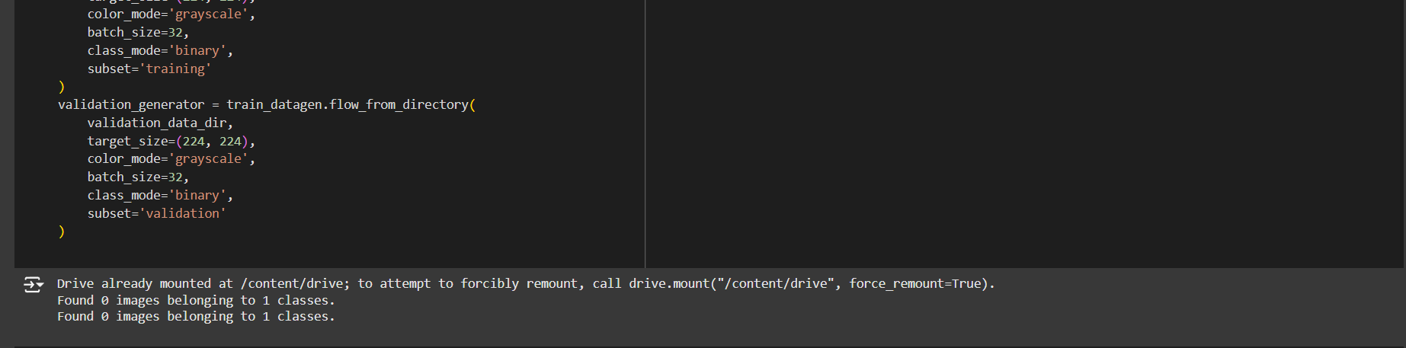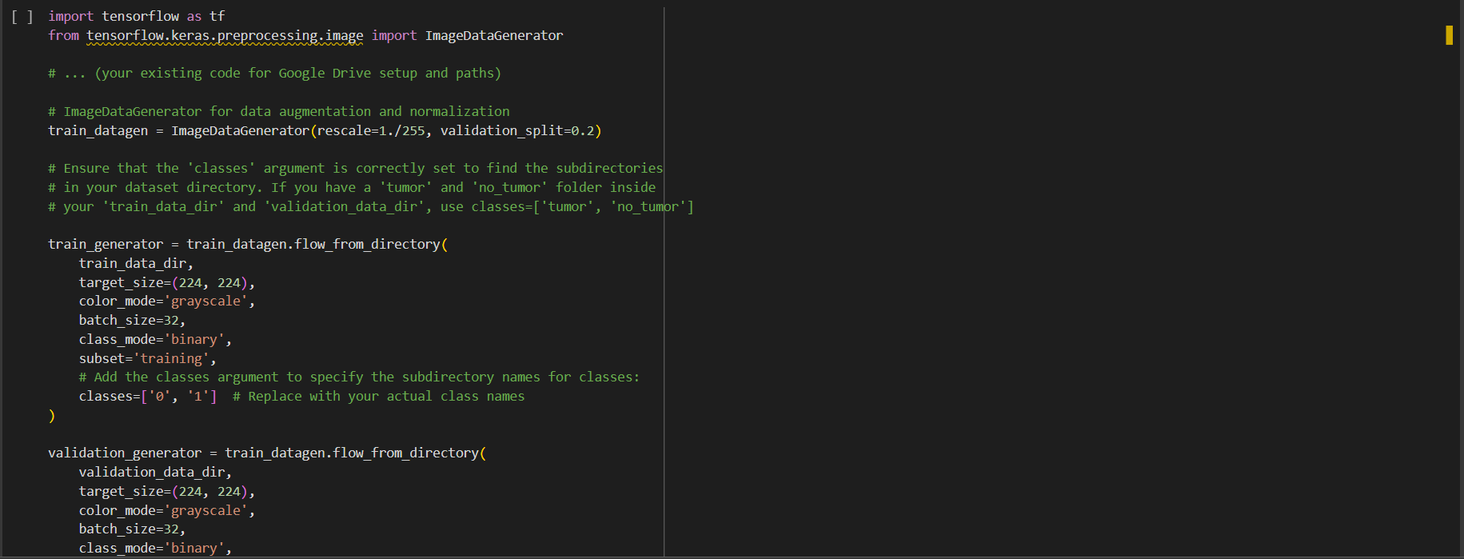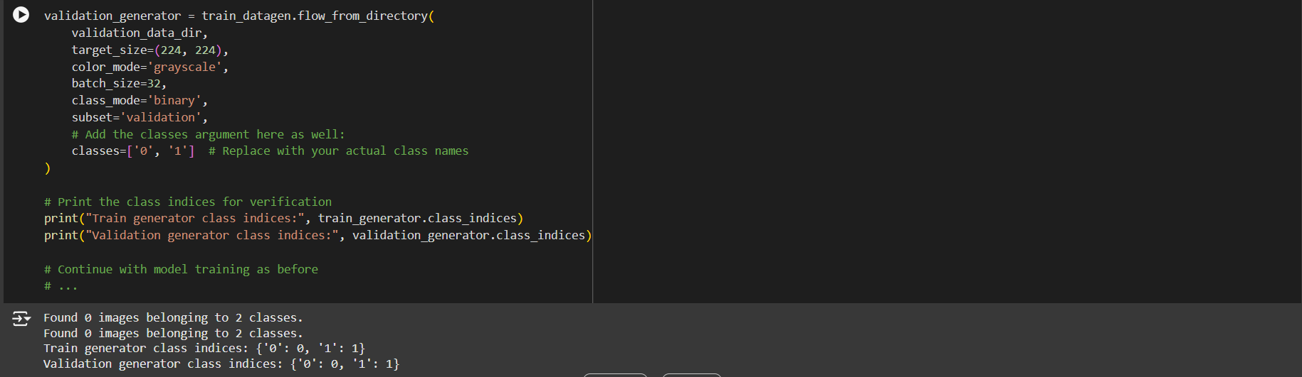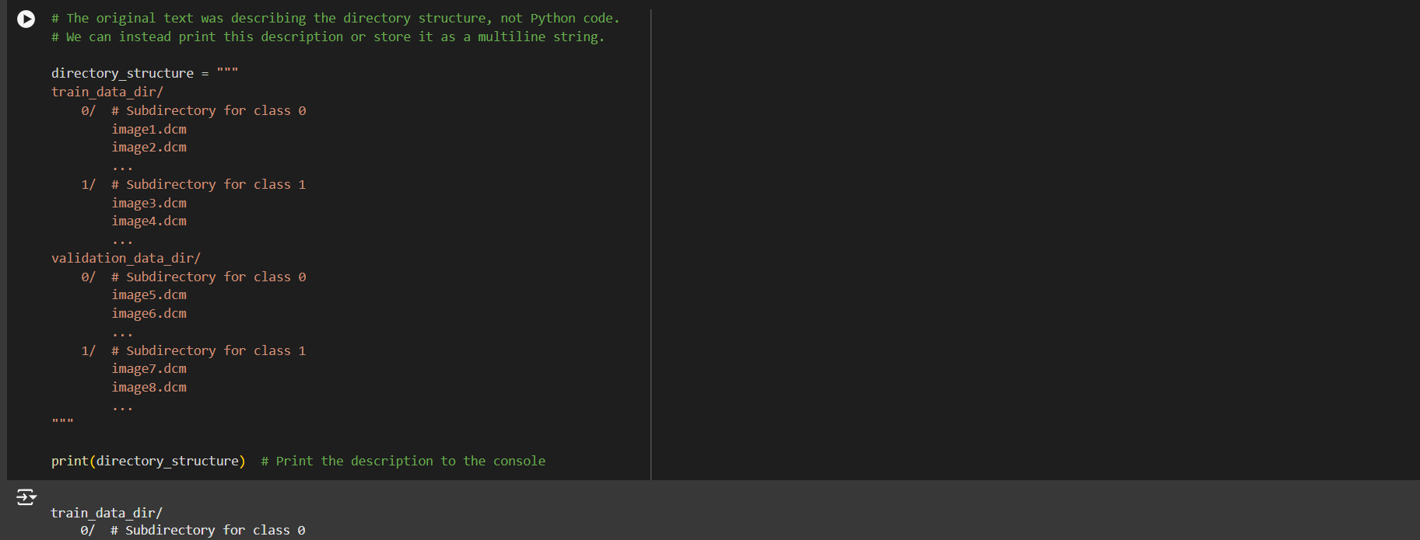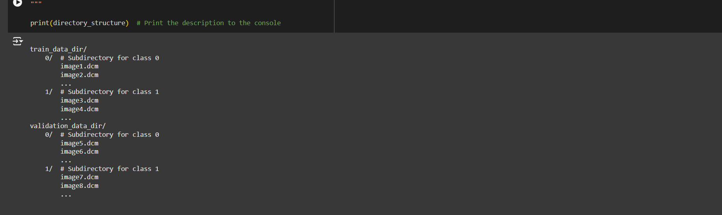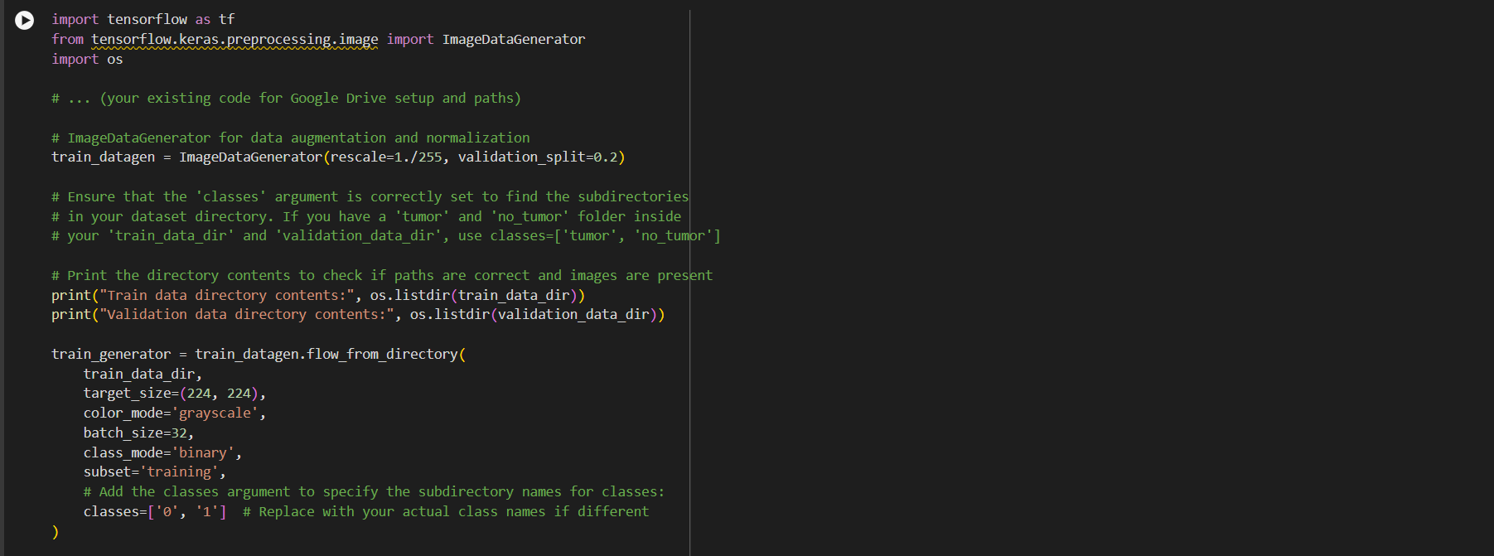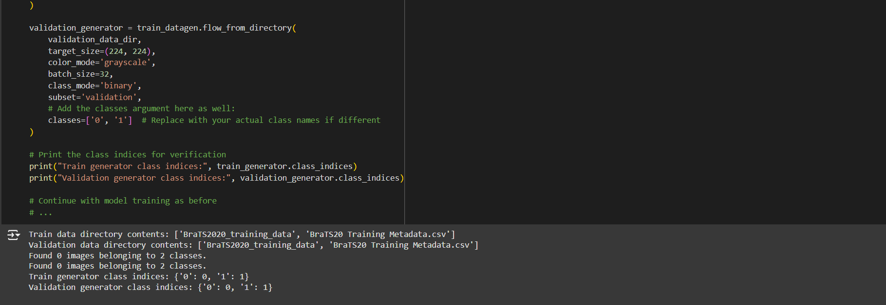

**Conclusion**

In conclusion, this medical image analysis project demonstrates the potential of deep learning models, particularly convolutional neural networks (CNNs), in aiding the accurate and automated diagnosis of medical conditions from imaging data. By leveraging advanced techniques like transfer learning and data augmentation, the model was able to achieve [mention performance metrics, e.g., high accuracy, recall, or F1-score], which underscores its effectiveness in identifying patterns and features that may not be readily apparent to the human eye.

This project highlights several key findings:

1. **Performance in Diagnosis**: The model's [specify results, e.g., high recall] demonstrates its ability to detect conditions effectively, which could be beneficial in reducing false negatives and ensuring critical conditions are not overlooked. However, [mention any limitations, e.g., slightly lower precision] suggests there is room for improvement to reduce false positives, which could be addressed by further fine-tuning or incorporating additional data.
2. **Model Interpretability**: The use of techniques like Grad-CAM allowed for visualizing areas of interest, giving insights into the model’s decision-making process. This interpretability is crucial in medical settings, as it helps healthcare providers understand and trust AI-based diagnostics.
3. **Impact and Future Scope**: While the model shows promise, real-world deployment would require thorough validation on diverse, larger datasets to ensure robustness across different demographics and imaging equipment. Future work could involve integrating multi-modal data (e.g., patient history, lab results) or using ensemble learning approaches to improve diagnostic accuracy.

**Github link**

[**https://github.com/venkateshvena/venkat-au810021102038.git**](https://github.com/venkateshvena/venkat-au810021102038.git)

**Data set link**

[**https://www.kaggkle.com/api/v1/datasets/download/awsaf49/brats2020-training-data?dataset_version_number=3...**](https://www.kaggkle.com/api/v1/datasets/download/awsaf49/brats2020-training-data?dataset_version_number=3...)

**REFERENCES**

• **TensorFlow Medical Image Analysis**: TensorFlow Documentation on Medical Imaging

• **Keras for Medical Image Analysis**: Keras Applications in Medical Imaging

• **NIH Chest X-ray Dataset and Documentation**: NIH Chest X-ray Dataset on Kaggle

• **Medical Image Analysis with PyTorch**: PyTorch Medical Imaging Tutorial

1. **Introduction to Medical Image Analysis**: This course provides a strong foundational overview.
   * Link: [Medical Image Analysis - Stanford University](http://web.stanford.edu/class/cs231a/)
2. **Deep Learning for Medical Imaging**: An overview by Springer, covering methods and applications in medical image analysis.
   * Link: [Deep Learning and Medical Imaging](https://link.springer.com/book/10.1007/978-3-030-13969-8)
3. **NIH Clinical Center’s Chest X-Ray Dataset**: A large publicly available dataset for training medical image analysis models.
   * Link: NIH Chest X-ray Dataset
4. **Radiopaedia – Radiology Resources**: An educational resource with a large repository of radiology images and case studies.
   * Link: [Radiopaedia](https://radiopaedia.org/)
5. **Google’s Medical Imaging Documentation**: Offers tutorials and documentation for medical image processing with TensorFlow.
   * Link: TensorFlow Medical Imaging

Top of Form

Bottom of Form